**CHAPTER 4**

**PROPOSED METHODOLOGY**

**4.1 PRINCIPLE OF OPERATION**

A developing country must think ahead of developed countries in order to achieve the goal of 2020. In this way the country need to solve the existing problems and also think about the solutions for the upcoming problems. Then only the country can sustain in its path. In modern era the main problem that each and every country faces is waste management. Because due to the overpopulation every citizen in the country consume more product and also generates more wastes from it.

In this way, the wastes are the considered as main problem in our country. Some scientists are also think about different solutions like sending wastes into deep space, dumping into ocean, burning etc. But all these ideas will definitely have a drawback and there are lots of drawbacks are involved behind this. It also need billions of dollars to be spent on just experiment that never works. So the good idea is to move to recycling the wastes. Because it is the only solutions that need low cost, low harm to the environment and high advantages.

For this solutions, the Hybrid bin is a good product which helps to solve the above mentioned problems This Hybrid bin is an autonomous bin that segregates the household wastes into two categories based on their chemical properties. This system works with the help of sensors feedback and it segregates with the help of segregation plate. The entire process can be separated into three sections. They are Identification, Segregation and Storage. The first step helps to identify the incoming wastes that is thrown by the user into the bin. After the identification of wastes, the sensors will start to work and it senses the wastes for their property. After the identification of the waste, the bin start to segregate that waste using the segregator plate which will turn in both clock wise and anti-clock wise directions. After the segregation of the waste, the bin will store the waste in its bottom area that have two blocks. One is for degradable and the other is for non-degradable waste. The system will also notify the user if the bin is running out of storage via push notifications in user’s android mobile. The main objective of this Hybrid bin is to segregate the waste at source level. This bin is completely autonomous and it never needs any user interruption. As already said the working of the bin can be classified into three process.

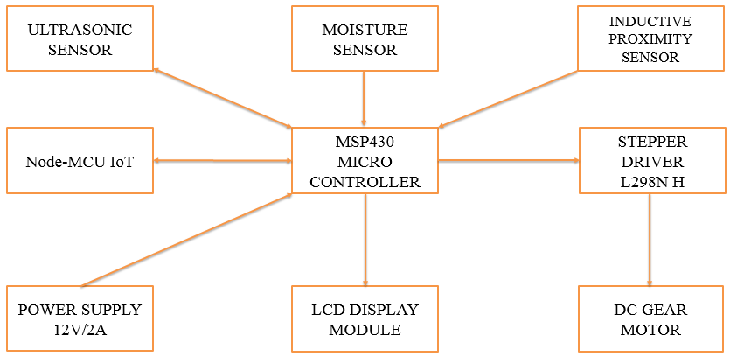**Figure 4.1 Block Diagram of Proposed System**

**4.1.1 Detection**

In this proposed design the bin uses the Ultrasonic sensor to detect the incoming of wastes. The ultrasonic sensor works with the help of sound waves in the range of 100 KHz to 50 MHz Hence the transmitter will transmit these sound waves for the predefined duration of time interval and the receiver will receive the reflected waves in the case of any material placed in front of the sensor.

Then the controller will check for the duration taken by the sensor to transmit and receive the sound waves and this time will be calculated using the formula of distance, time, speed. Here in this system the Ultrasonic sensor is used as a trigger for the upcoming levels of the Hybrid bin. Hence the duration taken by the sensor will be stored in the duration value and this duration will be used to find the wastes which is near by the sensor. Hence the sensor gives the value 1 if it detects any wastes in front of it or otherwise it will return 0. These values will be used to check the property of the waste materials in upcoming levels of the Hybrid bin.

**4.1.2 Segregation**

In Segregation technique the bin uses variety of sensors for the identification of the property of the wastes. There are two types of sensors are used here. One is inductive proximity sensor and the other is Moisture sensor. These two sensors are directly connected to the micro controller for getting feedback.

**4.1.2.1 Metal Detection**

The Inductive proximity sensor is used as a metal detector in order to detect the metal in the wastes. This is working with the following principle. Inductive proximity sensors are used for non-contact detection of metallic objects. Their operating principle is based on a coil and oscillator that creates an electromagnetic field in the close surroundings of the sensing surface.

The presence of a metallic object (actuator) in the operating area causes a dampening of the oscillation amplitude. The rise or fall of such oscillation is identified by a threshold circuit that changes the output of the sensor. The operating distance of the sensor depends on the actuator's shape and size and is strictly linked to the nature of the material.

**4.1.2.2 Degradable Waste Detection**

Soil moisture sensor consist of two conducting plates which function as a probe and acting as a variable resistor together. When the sensor is inserted into the water, the resistance will decrease and get better conductivity between plates. Soil moisture sensor has two conducting plates. First plate is connected to the +5Volt supply through series resistance of 10K ohm and second plate is connected directly to the ground. The output will change in the range of 0 – 5 Volt, in proportion with change in content of water in the soil. Ideally, when there is zero moisture in soil, the sensor acts as open circuit i.e. infinite resistance.

For this condition, we get 5V at the output. Here we are using this moisture sensor in order to find the food material and all other degradable materials. Because every degradable material will have some moisture inside it. By sensing that value we can predict the material property with that sensor value.

These sensor values will be given to the controller and the controller will process these feedback and decides whether the material is degradable or not. After the identification of the sensor values, the controller will send the signal to the Stepper motor in order to drive the segregator plate. The segregator plate is directly attached to the stepper motor via rotator arm welded with the motor.

The motor is driven with the help of stepper motor driver L298N H-Bridge. This driver will be given with a 12V power supply from the power adopter and it will get the control signal from the microcontroller.

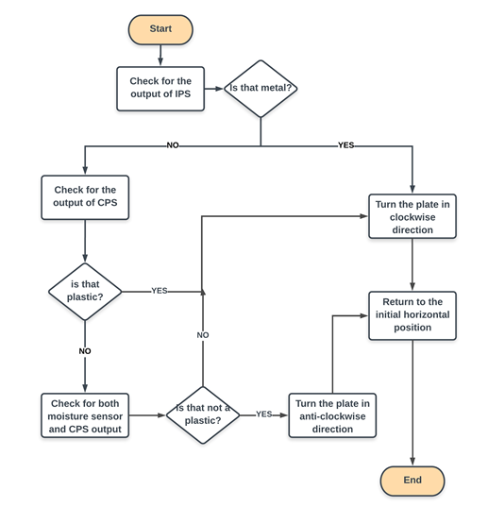

**Figure 4.2 Process Flow of Proposed System**

So if the sensor feedback gives the output that the waste is degradable then the stepper motor will rotate up to 45 degree in clockwise direction and the waste will be dropped in the degradable waste storage side. On the other hand if the sensor feedback gives the values that is the waste is non-degradable means, the stepper motor will be driven up to 45 degree in anti-clock wise direction. Hence now also the non-degradable waste will be dropped in its respective side.

**4.1.2.3 Control Unit**

The MSP430 can be used for low powered [embedded devices](https://en.wikipedia.org/wiki/Embedded_devices). The [current](https://en.wikipedia.org/wiki/Electric_current) drawn in idle mode can be less than 1 µA. The top CPU speed is 25 MHz it can be throttled back for lower power consumption.

The MSP430 also uses six different low-power modes, which can disable unneeded clocks and CPU. Additionally, the MSP430 is capable of wake-up times below 1 microsecond, allowing the microcontroller to stay in sleep mode longer, minimizing its average current consumption. The device comes in a variety of configurations featuring the usual peripherals. Here this micro controller is used because it is a low power micro controller and it will save the power when not in use. Each and every sensor and devices are connected to the controller and the controller will control all the devices with the help of sensor outputs.

**4.1.3 Waste Storage and Management**

In Segregation technique the bin uses variety of sensors for the identification of the property of the wastes. There are two types of sensors are used here. One is inductive proximity sensor and the other is Moisture sensor. These two sensors are directly connected to the micro controller for getting feedback.

Then after the storage, the user will get push notifications in their mobile phone via SMS inn case if the bin is running out of waste storage. This will be done with the help of NODE-MCU IOT module. The NODE-MCU IOT will work as a sender of SMS to the predefined phone number. NODE-MCU IOT Modules are one of the commonly used communication modules in embedded systems.

A NODE-MCU IOT Module is used to enable communication between a microcontroller or a microprocessor and the NODE-MCU IOT / GPSR Network. A NODE-MCU IOT MODEM comprises of a NODE-MCU IOT Module along with some other components like communication interface (like Serial Communication – RS-232), power supply and some indicators. With the help of this communication interface, we can connect the NODE-MCU IOT Module on the NODE-MCU IOT MODEM with an external computer (or a microcontroller).

NODE-MCU IOT Module allow microcontrollers to have a wireless communication with other devices and instruments. Such wireless connectivity of microcontroller opens up to wide range of applications like Home Automation, Home Security Systems, Disaster Management, Medical Assistance, Vehicle Tracking, Online Banking, E – Commerce etc. to name some. Before going in to the details about the NODE-MCU IOT/ Module, we will first see a few basic things like NODE-MCU IOT Module and System.